**Project Design Phase-II**

**Technology Stack (Architecture & Stack)**

|  |  |
| --- | --- |
| Date | 6 June 2025 |
| Team ID | LTVIP2025TMID38618 |
| Project Name | Revolutionizing Liver Care : Predicting Liver Cirrhosis using Advanced Machine Learning Techniques |
| Maximum Marks | 4 Marks |

**Technical Architecture:**

The Deliverable shall include the architectural diagram as below and the information as per the Components & Technologies & Application Characteristics

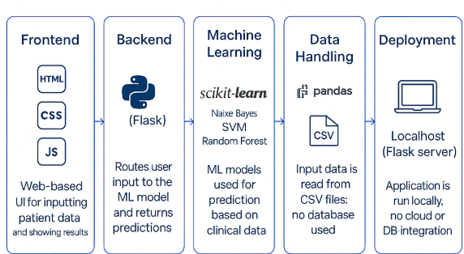

**Table-1 :** **Components & Technologies:**

|  |  |  |  |
| --- | --- | --- | --- |
| **S.No** | **Component** | **Description** | **Technology** |
|  | User Interface | Web interface for clinicians to input data and view predictions | HTML, CSS, JavaScript |
|  | Application Logic-1 | Data preprocessing and handling missing/categorical values | Python (pandas, NumPy) |
|  | Application Logic-2 | Model training, prediction, and evaluation | Python (scikit-learn) |
|  | Application Logic-3 | Flask-based integration to link frontend and backend | Python (Flask) |
|  | File Storage | Store model files and datasets locally or in GitHub repo | Local Filesystem |
|  | Machine Learning Model | Predicts whether a patient has liver cirrhosis | Naive Bayes, SVM, Random Forest,Logistic regression, |
|  | Infrastructure (Server / Cloud) | Application runs locally using Flask; can be extended to cloud | Local (Flask server) |

**Table-2: Application Characteristics:**

| **S.No** | **Characteristics** | **Description** | **Technology** |
| --- | --- | --- | --- |
|  | Open-Source Frameworks | Frameworks and libraries used for development | Flask, scikit-learn, pandas |
|  | Security Implementations | Application is local; data privacy ensured through offline processing | Local-only use; no cloud auth |
|  | Scalable Architecture | Can be scaled using microservices or hosted on cloud in future | Flask + Modular Python files |
|  | Performance | Optimized with preprocessed data and saved models for fast predictions | Flask,pandas |